LSTM and HMM Comparison for Home Activity Anomaly Detection
Yi-Fei Tan¹, Soon-Chang Poh¹, Xiaoning Guo¹, Soon-Nyean Cheong¹, Chee-Pun Ooi¹, Wooi-Haw Tan¹,
1. Faculty of Engineering, Multimedia University, Cyberjaya, Malaysia
yftan@mmu.edu.my, psoonchang@gmail.com, guo.xiaoning@mmu.edu.my, sncheong@mmu.edu.my, cpooi@mmu.edu.my, twhaw@mmu.edu.my

Abstract—Behavioral changes in daily home activities may be linked with health problems. Therefore, anomaly detection on sequence pattern of home activities is important for healthcare monitoring. In this paper, an anomaly detection method based on Long Short-Term Memory (LSTM) neural network is proposed to detect anomalies on sequence pattern of home activities. A comparison study of LSTM and Hidden Markov Model (HMM) was conducted to evaluate their performance under different training set size and model’s hyperparameters. The experimental results demonstrated that LSTM is comparable to HMM in detecting anomalies on sequence pattern of home activities. The test accuracies of the best LSTM and HMM models are both 87.50%.
Keywords—Sequence pattern, LSTM, HMM, anomaly detection, home activity

Introduction
Human activity recognition is an active research field which can be used in multiple applications in areas such as assisted living, healthcare and the game industry [1]. In the context of assisted living, there are several researches focusing on recognizing home activities. Monitoring activities including sleeping, showering and eating by using sensors and machine learning algorithms [2].
Activity recognition system requires the collection of a person’s home activities data. These collected data provide historical records of home activities that may be used to detect anomalies in home activities. The collection of all activities happened in one day from 0:00 to 23:59 is referred to as daily home activity sequence, as shown in Fig. 1. Each daily home activity sequence may be considered as a single piece of data instance.

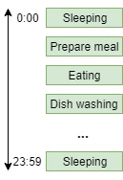
- An example of daily home activity sequence

There are two types of anomalies which can be detected for home activities, they are time anomaly and sequence pattern anomaly.
Time anomaly refers to changes in routine of a home activity. When a certain activity that had been consistently carried out at a specific time of each day, a change in the timing of this activity is considered a time anomaly. In our previous work [3], we proposed a method to detect time anomaly by using a database and threshold that resulted in 84.85% test accuracy.
On the other hand, sequence pattern anomaly refers to the changes in the orders of home activities that had been carried out. Past works that focused on sequence pattern anomaly detection of home activities used methods such as Hidden Markov Model (HMM) and PrefixSpan algorithm.
In [4], Forkan and colleagues demonstrated an anomaly detection method based on HMM to detect sequence pattern anomalies. The number of states is a hyperparameter of the HMM model. The optimal number of states is unknown. Forkan and colleagues selected a few choices of number of states, evaluate their performance using an artificially generated dataset synthesized based on a public dataset [5] and chose the number of states with the best performance. The experiment demonstrated that HMM worked quite well with an accuracy around 90%.
In [6], Hoque and partners used a combination of PrefixSpan algorithm and statistical method to detect anomalies on sequence pattern of home activities. First, they used a sequential pattern mining algorithm called PrefixSpan to find out frequent short segments of home activities from the dataset. Then, they modeled the duration and interval between activities of these extracted short segments to detect anomalies in the sequence pattern.
The shortcoming of the PrefixSpan method is that it can only captures frequent short segments, a minority of the data instances. Whereas the HMM-based method is capable of utilizing entire sequence of data instances to build the anomaly detection model. In comparison, HMM-based method is a more complex and powerful method of the two methods.
HMM is a machine learning algorithm which can capture the pattern of time series sequence data for classification [7]. Similarly, Long Short-Term Network (LSTM) neural network is also a sequence model which can capture patterns of time series data [8]. Therefore, the hypothesis is that LSTM can be used in sequence pattern anomaly detection of home activities data.
In this paper, we compared the performance of LSTM and HMM in sequence pattern anomaly detection under different training set size and model hyperparameters.
Moving forward, the paper is structured into the following sequence of subsections: (II) Methodology, (III) Results and Discussion and (IV) Conclusion and Future Work.

Methodology
Fig. 2 illustrates the methodology designed to conduct comparison study between LSTM and HMM to detect anomalies on sequence pattern of home activities. The following subsections describes each of the steps: (A) data collection, (B) data preparation, (C) modeling and (D) model evaluation.

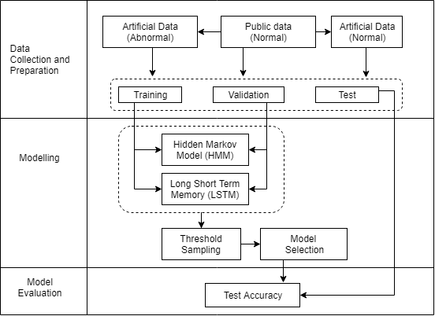
- Framework of analysis

Data Collection
Anomaly detection task requires two class of data namely normal and abnormal. The dataset used in this experiment is the “Aruba” dataset obtained from Center for Advanced Studies in Adaptive Systems (CASAS) of Washington State University [9]. It contains historical records of an adult woman volunteer’s home activities for 220 days. There are 11 types of activities such as preparing meal, relax, eating, work, sleeping, dish washing, toileting, enter home, leave home, housekeeping and respirate. The public dataset was used as normal data after data processing.
The abnormal data instances were artificially generated by randomly shuffling the final 5 activities of a normal data instance. This injects noise into data to simulate abnormality in carrying out daily home activities.

Data Preparation
The purpose of data preparation is to process the data into desirable format which the model requires. It consists of 3 steps which include noise removal, data processing and data partitioning.

Noise Removal: Noise refers to potion of data that has characteristics uncommon to the rest of the data. If noisy data were used during training process, it would affect the performance of the model. Therefore, noise in the dataset must be removed. There were 4 types of noise in the dataset. Firstly, some activities in the dataset happened in the duration of another activity (between the beginning and end of the second activity). This characteristic only applied to a very small portion of the dataset and they were removed. The second type of noise is an activity that had rarely occured. The activity “Respirate” was removed as it only occured for 6 times in the dataset. The third type of noise is due to variation of length of data instances. Some data instances have much fewer numbers of activites in an instance when compared to the rest of the dataset. Thus, data instances with number of activities less than 10 were removed. The final type of noise is repetitions of activity records. In the dataset, some activities were recorded consecutively (same activity occurred multiple times with close time interval) more than once. In this research, this type of repetitions was removed. After removing all these noisy data, the remaining data has a size of 156.

Data Processing: The second step of data preparation is data processing. Data processing aims to convert the cleaned data into desired format. The data format for LSTM and HMM are different. Following subsection (a) describes data processing step for LSTM. In subsection (b), we talk about data processing step for HMM.

Data Processing for LSTM: In this paper, the dictionary was created to represent different types of activities in the dataset. Up to this point, the dictionary consists of 10 types of activity such as preparing meal, relax, eating, work, sleeping, dish washing, toileting, enter home, leave home and housekeeping. In this step, an “EoS” symbol was added to the end of each data instance signifying the end of sequence (EoS). It was added so that the LSTM model can learn when the sequence should end during training. With the addition of “EoS”, the dictionary now consists of 11 symbols.
Each data instance was segmented into shorter segments by applying a sliding window of window size of 5 and step size of 1. In Fig. 3, the data processing step of a data instance for LSTM method is shown. Given a data instance, we denoted each activity in that data instance with a^{(i)} where i = 1,2, 3, …, m. By applying the sliding window using window size 5 and step size 1, we were able to split the data instance into shorter segments as input data and take the next activity as the corresponding target. For example, the first segment of the data instance is a vector of length 5 which consists of a⁽¹⁾ to a⁽⁵⁾ and its corresponding target is a⁽⁶⁾. The target data are vector of length 11 because we used one-hot representation to symbolize the target.

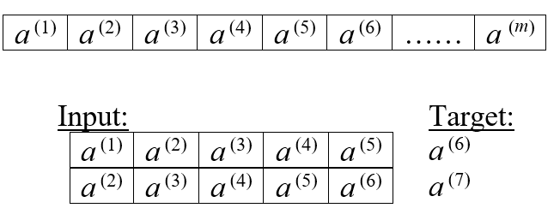
- Data processing of a data instance for LSTM

Data Processing for HMM: For HMM, we represent each type of activity with an integer. HMM takes the whole sequence of data instance as input. Therefore, further segmentation is not required.

Data Partitioning: : The total number of normal data instances is 156 after data processing. This data were later used in the experiments by setting up two datasets with different training set size labelled as Set A and Set B. For Set A, we took 100 normal instances and split them into training, validation and test set. For set B, 156 normal data instances were split into training, validation and test set. The details of data partitioning is given in Table I.
- Data Partitioning
 |  | Train | Validation | Test
Set A | Normal | 80 | 10 | 10
Set A | Abnormal | - | 10 | 10
Set B | Normal | 124 | 16 | 16
Set B | Abnormal | - | 16 | 16

Modeling
In this paper, the paradigm of anomaly detection method works by first training a machine learning algorithm to model the normal pattern of home activity sequences. Given a trained model and an unseen data instance, a score can be calculated. Then, the score is compared with a threshold to decide whether to classify the data instance as normal or abnormal.
The following subsection describes the modeling which includes LSTM, HMM, threshold sampling and model selection.
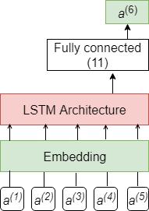
- LSTM model architecture for anomaly detection

LSTM: The main idea of LSTM-based method is to predict the next activity given a segment of the data instance. Before training, each of the data instance is segmented into shorter sequence as input. The next activity of each segment is taken as target. For example, in Fig. 4, the LSTM takes a segment with 5 consecutive activities denoted by a⁽¹⁾ to a⁽⁵⁾ as input and its corresponding next activity, a⁽⁶⁾ as target. The input vector has a length of 5 as each segment consists of 5 activities. The target vector has a length of 11 which is a one-hot representation of the next activity. The embedding layer converts each component of the input vector to a vector of length 5, resulting in an output matrix of shape 5×5. Then, the output matrix is passed to the LSTM layer. The final layer of the model is a fully connected neural network layer with 11 units and uses a Softmax activation function. During prediction, it outputs a prediction vector of length 11 when given 5 consecutive activities as input. The prediction vector is a prediction of the next symbol (an activity or “EoS”). Each components of the prediction vector is the probability that LSTM assign to each symbols of the dictionary. The elements of the prediction vector sum to 1. The loss function used to minimize discrepancies between prediction vectors and target vectors of the training set is the categorical cross entropy function. The LSTM architecture is a hyperparameter of this method. LSTM architecture refers to the number of layers of LSTM and the number of hidden units per LSTM layer. In this paper, 4 different LSTM architectures were evaluated. They were labelled using integer as shown in Table II.

- LSTM Architectures
Architecture | Number of LSTM layers | Number of units
1 | 1 | 32
2 | 1 | 64
3 | 2 | 32
4 | 2 | 64

Given an unseen data instance, the first step is to segment the data instance. Taking all the segments of a data instance as input, the model output a prediction vector for each of the segment. We can obtain a difference vector d for each pair of prediction vector p and target vector a by using (1). According to (2), a score is calculated by taking the L¹ norm for every difference vectors of the data instance, sum up these L¹ norms and normalize them.
d = a − p   
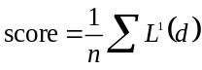 
The score used by LSTM is a function of error of prediction vectors and target vectors. If the given data instance is similar to the sequences used to train the LSTM model, the calculated score should be small. If the score of a data instance is greater than the threshold, that would suggest the data instance to be classified as anomalous and vice versa.

HMM: HMM is a doubly embedded stochastic process with an underlying stochastic process that is hidden but can only be observed through another set of stochastic processes that produce the sequence of observations [7]. HMM is characterized by number of states, N and the number of distinct observations, M [7].
In this work, M is 10 because there are 10 distinct types of activity in the dataset. The number of states N is an unknown hyperparameter of the model. In other words, the optimal number of states N is unknown. The systematic way is to select a few choices of N, evaluate their performance and choose the one with the best performance. In this research, we have evaluated 5 different choices of N which include 2, 4, 6, 8 and 10.
The score used by HMM-based anomaly detection method is the log-likelihood, log P(O|λ) where O refers to a data instance and λ refer to a trained HMM model. The log-likelihood is the log of the probability of a data instance given a trained model. If the unseen data instance has similar pattern as sequences of home activities used to train the HMM, the probability P(O|λ) computed for that data instance should be high. For anomaly detection, if the log-likelihood of that data instance is greater than the threshold, then it is classified as normal and vice versa.

Threshold Sampling: For both LSTM and HMM anomaly detection method, threshold is one of the hyperparameters of the model. The optimal choice of threshold is unknown. The natural way to select the threshold would be to sample a few threshold choices, examine their performance and choose the best one.

Given a trained model, a score was computed for every data instance in the validation set. Then, the minimum and maximum of these scores were taken as minimum and maximum of range of possible threshold. For each category of training set size and other hyperparameter (LSTM architecture for LSTM and number of states for HMM), 100 threshold choices were linearly sampled from its respective range of possible threshold. In this paper, the term model refer to a unique (LSTM or HMM) algorithm trained with different training set size and uses varying hyperparameters.

Model Selection: For HMM method, we examined 5 different number of states with 100 threshold choices and 3 different training set size which results in 1500 models with varying number of states, threshold and training set size. As for LSTM, we examined 4 different LSTM architectures with 100 threshold choices and 3 different training set size results in 1200 models.
An evaluation metric known as F1 score is used to evaluate the model’s performance. We calculated F1 score for each model and select the model with highest F1 score as the best model.

Model Evaluation
Model evaluation is a step which evaluates the selected model on a test set with an evaluation metric, accuracy. The purpose of model evaluation is to ensure the consistency of the model’s performance. A good model should be able to generalize well to unseen testing data with a negligible difference in validation accuracy and test accuracy.

Results and Discussion
In subsection A, we show normal and abnormal scores calculated for HMM and LSTM models. In subsection B, the F1 scores of the best models are displayed. Finally, we talk about the result of model evaluation of the best HMM and LSTM model.
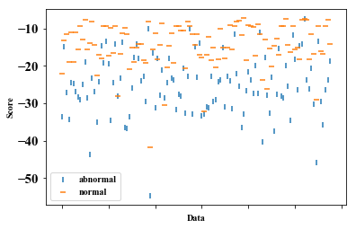
- Normal and abnormal scores of test set under HMM model
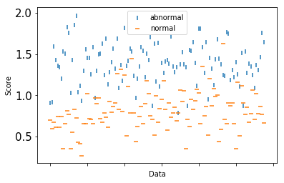
- Normal and abnormal scores of test set under LSTM model

Normal and Abnormal Scores
Fig. 5 and Fig. 6 show the normal scores and abnormal scores of data instances in test set calculated with HMM and LSTM anomaly detection model. Through manual estimation, the normal scores and abnormal scores are visibly clustered separately around different ranges of score with some outliers. Outliers refer to the score of data instance of one class appearing in cluster of another class.

F1 Scores
For each category of training set size and number of states, we evaluated 100 HMM models and selected the one with the highest F1 score. The F1 scores of the selected models are listed in Table III. For Set A, the F1 score increases, levels off and decreases with number of states. For Set B, the F1 score increases with number of states. Overall, the selected model is a Set B model with number of states of 10 and the highest F1 score of 83.33%.
For LSTM, the selected models of each category of training set size and LSTM architecture have F1 scores as detailed in Table IV. For Set A, the model with the highest F1 score of 90% used a 2 layer LSTM with 64 units. For Set B, architecture 1 and 2 shared the highest F1 score of 88.24%.
- F1 Scores of HMM Models
 | Set A | Set B
Number of States | F1 Score
2 | 66.67 | 68.18
4 | 81.82 | 74.07
6 | 81.82 | 81.25
8 | 81.82 | 82.76
10 | 78.26 | 83.33

- F1 Scores of LSTM Models
 | Set A | Set B
Architecture | F1 Score
1 | 84.21 | 88.24
2 | 81.82 | 88.24
3 | 84.21 | 84.85
4 | 90.00 | 83.33

Overall, the complexity of the model contributed by number of states and LSTM architecture does not have clear correlation with the performance of the model. It may be due to the small training set size. However, this training set size is reasonably due to the nature of the task (each day data is considered a single data instance).

Results of Model Evaluation
- Performance Metrics Of Best HMM Models
 | Set A |  | Set B
 | Validation | Test | Validation | Test
Precision | 75.00 | 66.67 | 75.00 | 87.50
Recall | 90.00 | 60.00 | 93.75 | 87.50
F1 score | 81.82 | 63.16 | 83.33 | 87.50
Accuracy | 80.00 | 65.00 | 81.25 | 87.50
Number of States | 4 |  | 10

Table V consists of the performance metrics for the best HMM models for Set A and Set B. Overall, the best HMM model in terms of accuracy we found is Set B’s model with a higher test accuracy of 87.50%.
- Performance Metrics Of Best LSTM Models
 | Set A |  | Set B
 | Validation | Test | Validation | Test
Precision | 90.00 | 75.00 | 77.78 | 83.33
Recall | 90.00 | 90.00 | 87.50 | 93.75
F1 score | 90.00 | 81.81 | 82.35 | 88.24
Accuracy | 90.00 | 80.00 | 81.25 | 87.50
Architecture | 4 |  | 1

Table VI lists the performance of the best LSTM models for Set A and Set B. The overall best model in terms of accuracy is the Set B’s model with a test accuracy of 87.50% and used a single layer. Set A model is not chosen despite it has a higher F1 score of 90%. It has an inconsistent performance on validation set and test set. Its test accuracy was much lower at 80%, which is 10% less than its validation accuracy. It overfitted the training set and therefore failed to generalize well to unseen data.

Conclusion and Future Work
For detecting sequence pattern anomaly in daily home activity sequence, an anomaly detection model based on LSTM was proposed. The experiments conducted with public dataset revealed that LSTM has a comparable performance when compared to HMM in this task in terms of accuracy, precision and recall. Currently, the LSTM anomaly detection method has a weakness. It requires 5 initial activities of the sequence as input, which means it is unable to detect anomaly in these 5 initial activities of the day because the current LSTM layer used is unidirectional. For future work, LSTM architecture such as bidirectional LSTM may be investigated and studied to counter this shortcoming.

References
- S. Ranasinghe, F. A. Machot, and H. C. Mayr, “A review on applications of activity recognition systems with regard to performance and evaluation”, International Journal of Distributed Sensor Networks, July 2016.
- D. Cook, “Learning setting-generalized activity models for smart spaces”, IEEE Intelligent Systems, vol. 27, no. 1, pp. 32-38, Jan.-Feb. 2012.
- S. Poh, Y. Tan, S. Cheong, C. Ooi, W.Tan, “Anomaly detection for elderly in-home activity monitoring”, presented at 3rd International Conference on Electrical, Electronic, Communication and Control Engineering (ICEECC), Johor Bahru, Malaysia, 2018.
- A. Forkan, I. Khalil, Z. Tari, S. Foufou, and A. Bouras, “A context-aware approach for long-term behavioural change detection and abnormality prediction in ambient assisted living”, Pattern Recognition, vol. 48, no. 3, pp. 628-641, 2015.
- J. Ordonez, P. de Toledo, and A. Sanchis, “Activity recognition using hybrid generative/discriminative models on home environments using binary sensors”, Sensors 2013, pp. 5460–5477, 2013.
- E. Hoque, R. F. Dickerson, S. M. Preum, M. Hanson, A. Barth and J. A. Stankovic, “Holmes: a comprehensive anomaly detection system for daily in-home activities”, 2015 International Conference on Distributed Computing in Sensor Systems, Fortaleza, 2015, pp. 40-51.
- L. R. Rabiner, “A tutorial on hidden markov models and selected applications in speech recognition”, Proceedings of the IEEE, vol. 77, no. 2, pp. 257-286, Feb. 1989.
- S. Hochreiter and J. Schmidhuber, “Long Short-term Memory”, Neural Computation, vol. 9, pp. 1735-1780, November 1997.
- D. Cook. “Learning Setting-generalized Activity Mdoels for Smart Spaces”, IEEE Intelligent System,s vol. 27, issue 1, pp. 32 - 38 , 2012.

